1.Matrix addition.
import java.util.*;
public class matrixadd {
public static void main(String[] args) {
int r, c, i, j;
int a[][] = new int[15][15];
int b[][] = new int[15][15];
int add[][] = new int[15][15];
Scanner s = new Scanner(System.in);
System.out.println("enter number of rows ");
r = s.nextInt();
System.out.println("enter number of col ");
c = s.nextInt();
System.out.println("enter ele of a matrix...");
for (i = 0; i < r; i++) {
for (j = 0; j < c; j++) {
a[i][j] = s.nextInt();
}
}
System.out.println("enter ele of b matrix...");
for (i = 0; i < r; i++) {
for (j = 0; j < c; j++) {
b[i][j] = s.nextInt();
}
}
for (i = 0; i < r; i++) {
for (j = 0; j < c; j++) {
add[i][j]=a[i][j]+b[i][j];
}}
System.out.println("result matrix...");
for (i = 0; i < r; i++) {
for (j = 0; j < c; j++) {
System.out.println(add[i][j]);
}
}
}}

Output.
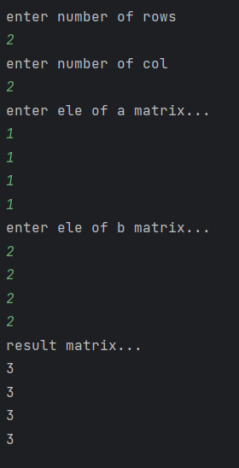

2.Matrix subtraction.

import java.util.*;
public class matrixsub {
public static void main(String[] args) {
int r, c, i, j;
int a[][] = new int[15][15];
int b[][] = new int[15][15];
int sub[][] = new int[15][15];
Scanner s = new Scanner(System.in);
System.out.println("enter number of rows ");
r = s.nextInt();
System.out.println("enter number of col ");
c = s.nextInt();
System.out.println("enter ele of a matrix...");
for (i = 0; i < r; i++) {
for (j = 0; j < c; j++) {
a[i][j] = s.nextInt();
}
}
System.out.println("enter ele of b matrix...");
for (i = 0; i < r; i++) {
for (j = 0; j < c; j++) {
b[i][j] = s.nextInt();
}
}
for (i = 0; i < r; i++) {
for (j = 0; j < c; j++) {
sub[i][j]=a[i][j]-b[i][j];
}}
System.out.println("result matrix...");
for (i = 0; i < r; i++) {
for (j = 0; j < c; j++) {
System.out.println(sub[i][j]);
}
}
}}

Output.

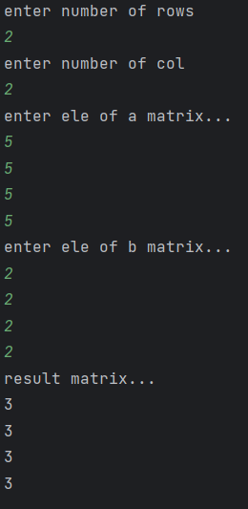

3.Matrix multiplication.
import java.util.*;
public class matmul {
public static void main(String[] args) {
int r,c,i,j,k;
int a[][]=new int[15][15];
int b[][]=new int[15][15];
int mul[][]=new int[15][15];
Scanner s=new Scanner(System.in);
System.out.println("enter number of rows ");
r=s.nextInt();
System.out.println("enter number of col ");
c=s.nextInt();
System.out.println("enter ele of a matrix...");
for(i=0;i<r;i++){
for(j=0;j<c;j++)
{
a[i][j]=s.nextInt();
}
}
System.out.println("enter ele of b matrix...");
for(i=0;i<r;i++){
for(j=0;j<c;j++)
{
b[i][j]=s.nextInt();
}
}
for(i=0;i<r;i++){
for(j=0;j<c;j++)
{
mul[i][j]=0;
for(k=0;k<c;k++){
mul[i][j]+=a[i][k]*b[k][j];}
}
}
System.out.println("a matrix...");
for(i=0;i<r;i++){
for(j=0;j<c;j++)
{
System.out.println(a[i][j]);
}
}
System.out.println("b matrix...");
for(i=0;i<r;i++){
for(j=0;j<c;j++)
{
System.out.println(b[i][j]);
}
}
System.out.println("result matrix...");
for(i=0;i<r;i++){
for(j=0;j<c;j++)
{
System.out.println(mul[i][j]);
}
}
}
}

output.
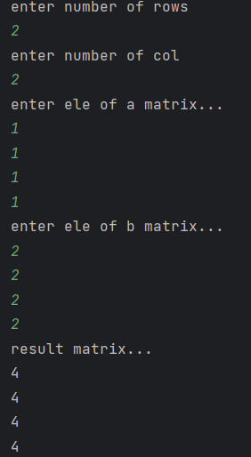
4.Average of 15 students marks in array.
import java.util.*;
public class array {
public static void main(String[] args) {
int a[]=new int[20];
int i,sum=0,avg=0;
Scanner s=new Scanner(System.in);
System.out.println("enter 15 marks");
for(i=0;i<15;i++){
a[i]=s.nextInt();
sum+=a[i];
}
System.out.println("sum = "+sum);
avg=sum/15;
System.out.println("average = "+avg);
}
}

Output.
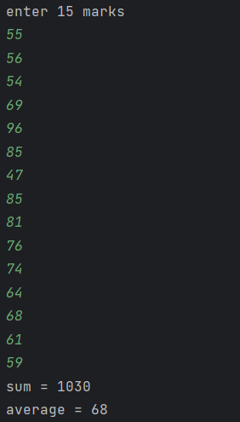

5.Area of rectangle (class).
public class rectangle {
void rect(int l,int b){
int area=l*b;
System.out.println("area of rectangle = "+area);
}
public static void main(String[] args) {
rectangle r=new rectangle();
r.rect(10,5);
}
}

Output.

6.Area of circle (class).
public class circle {
void cir(int r){
double area=3.14*r*r;
System.out.println("area of circle = "+area);
}
public static void main(String[] args) {
circle c=new circle();
c.cir(5);
}
}

Output.
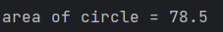

7.Area of triangle (class).
public class areaoftriangle {
void triangle(int b,int h){
double area=0.5*b*h ;
System.out.println("area of triangle = "+area);
}
public static void main(String[] args) {
areaoftriangle t=new areaoftriangle();
t.triangle(12,10);
}
}

Output.

8.Simple interest(class).
import org.w3c.dom.ls.LSOutput;
import java.util.*;
public class roi {
void interset(int p,int y,int r){
int roi=p*y*r/100;
System.out.println("interset = "+roi);
}
public static void main(String[] args) {
int p,y,r;
Scanner s=new Scanner(System.in);
System.out.println("enter principle amount ");
p=s.nextInt();
System.out.println("enter no of years ");
y=s.nextInt();
System.out.println("enter rate of interset ");
r=s.nextInt();
roi r1=new roi();
r1.interset(p,y,r);
}
}

Output.
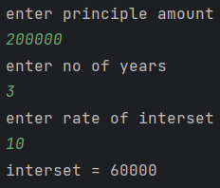

9.Sum of series(class).
import java.util.*;
public class sos {
void sumofseries(int n){
int sum=0;
for(int i=0;i<=n;i++){
sum+=i;
}
System.out.println("sum = "+sum);
}
public static void main(String[] args) {
int n;
Scanner s=new Scanner(System.in);
System.out.println("enter limit ");
n=s.nextInt();
sos o=new sos();
o.sumofseries(n);
}
}

Output.
